CSE220: Data Structures (Lab)

Fall 2024

Lab Quiz - 05

Duration: 30 Minutes

| Name: | ID: | Section: |
| --- | --- | --- |

### **Question 1 [15 Points]**

Ayaan is playing an online game where he must attack a foreign land. In the game, each city along the route is represented as a node in a Binary Search Tree (BST). Each node contains the energy cost required to conquer that city and has connections to two other cities: one on the left and one on the right.

The journey begins at the root node, which represents the starting city. As Ayaan traverses toward his target land, he must defeat all cities along the way.

To help Ayaan plan his strategy, the system also calculates the total energy required to reach the target land. Starting from the root node, the system multiplies the energy costs of all nodes visited during the traversal. If the target city exists, the total energy cost is displayed. Otherwise, the system informs Ayaan that the "route does not exist" and no energy calculation is performed.

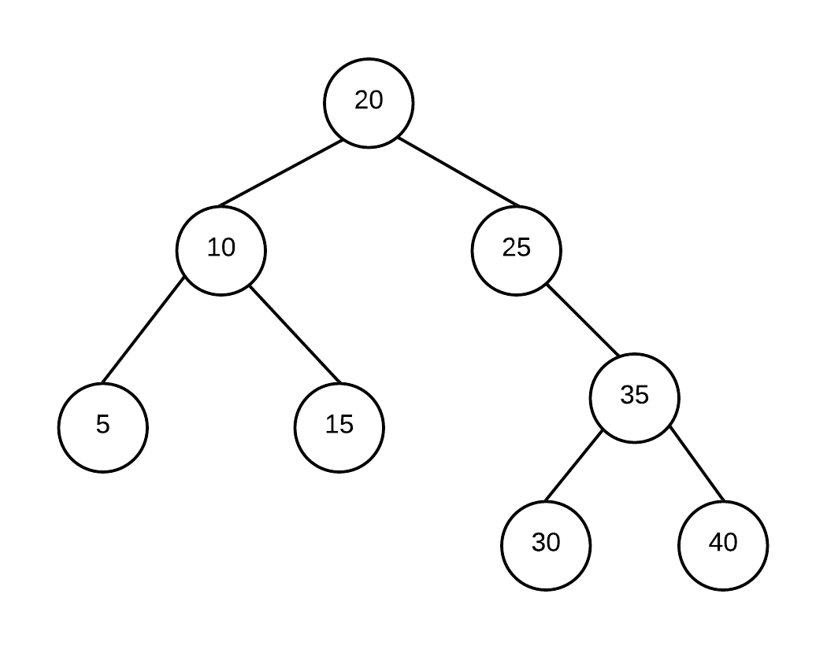

**Hint:**

**The root city's energy is included.**

| **Sample Input** | **Sample Output** | **Explanation** |
| --- | --- | --- |
| calculate_energy(root,30) | 525000 | The route is 20->25->35->30.  So multiplies of cost is 20*25*35*30= 525000 |
| calculate_energy(root,34) | route does not exist |  |

**You need to construct the node class and the BST by yourself.**